|  |
| --- |
|  |
| MTN.BI.07 Star Schema Basics |

|  |  |  |  |  |  |
| --- | --- | --- | --- | --- | --- |
| REVISION HISTORY | | | | | |
| Ver. | Description of Change | Author | Date | Approved | |
| Name | Effective Date |
| 1.0 | Initial status | Anastasiya Khilko | 09-NOV-2012 |  |  |

Contents

1. Data Modelling Task 3

2. Analytical task 4

# Data Modelling Task

* 1. **Select the Business Process**

The business process is product’s sales. It is a standard activity performed by an organization. For this reason it is necessary and useful to know what product was sold, who was a customer, when and where the product was sold and etc.

* 1. **Declare the Grain**

The grain is one sale of product to customer in a particular date.

* 1. **Identify the Dimensions**

Dimensions should answer questions like Who? What? Where? When? How much?

Such dimensions like Customers, Stores, Products, Date, Employees were identified.

* Dimension Customers include full information about customers: customer id, name, surname, address, email.
* Dimension Products has product id, product name, product category.
* Dimension Stores consists of id and location of the particular store.
* Dimension Date includes only sales date id and particular dates.
* Dimension Employees include full information about employee: employee id, name, surname, address, email.
  1. **Identify the Facts**

Fact is record about a single event in business process. Fact table include primary keys of dimensions as foreign keys and some measures. In this case there is one measure – amount.

**A star scheme:**

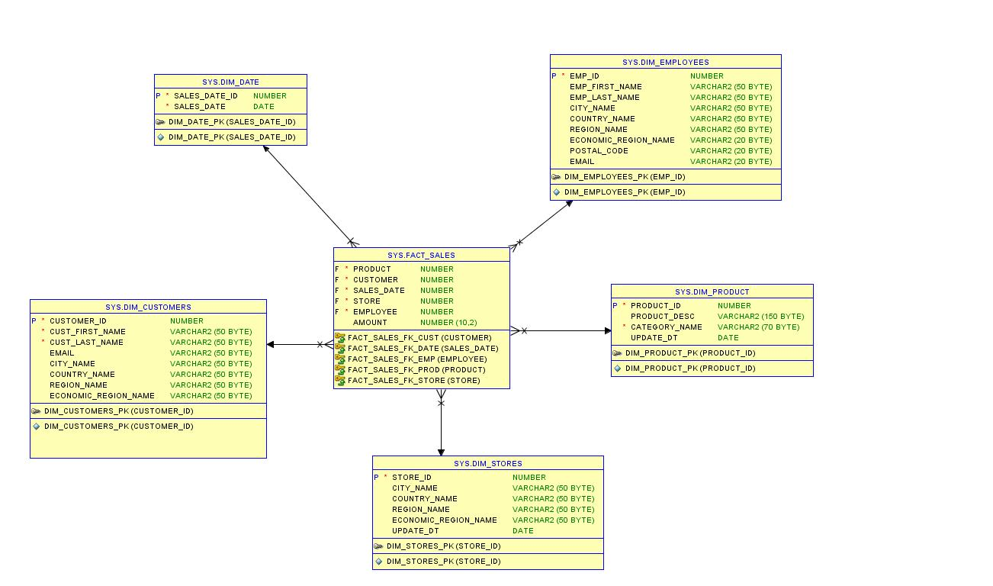

**A snowflake scheme:**

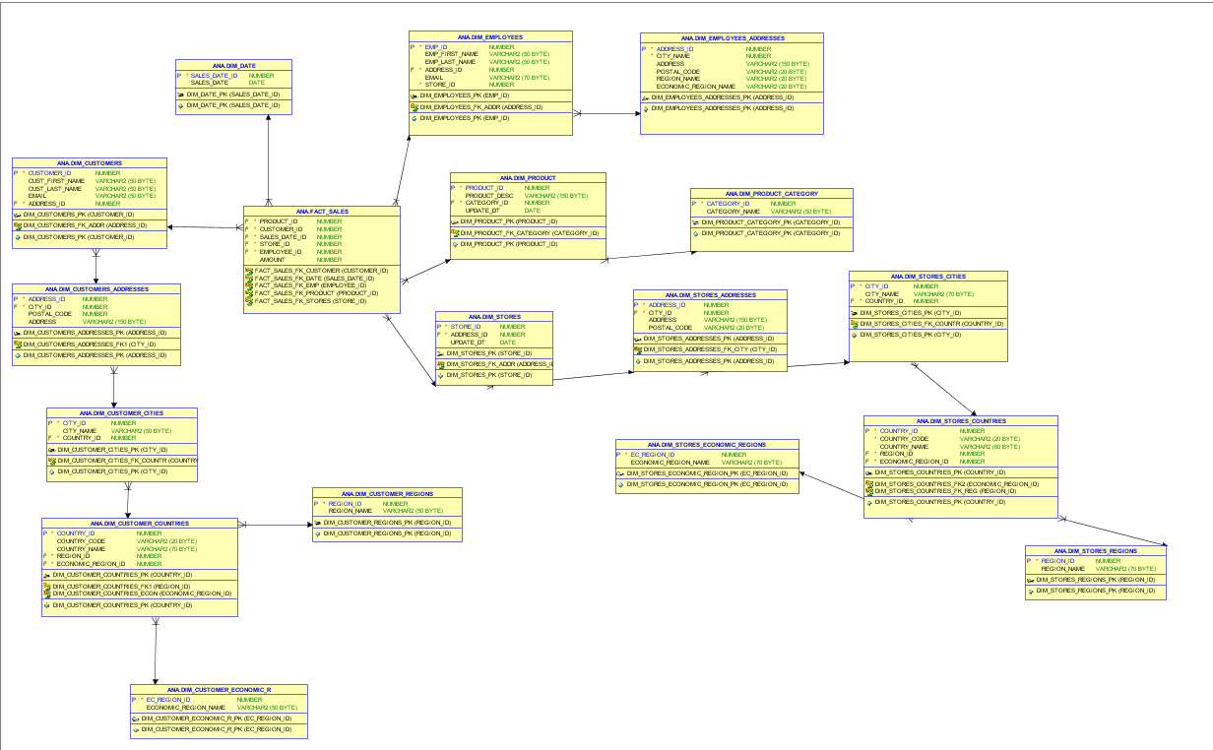

# Analytical task

1. Huntsman is the most popular and largest team of cutters and London tailors. It specializes in costume tailoring. And more often on individual orders.
2. The problems that business is facing because of poor data management are difficulties with understanding clothing preferences among people from different age categories, learning reliable information such time spent for sewing for one customer and how the cost depends on this time.
3. DWH will be build to provide consistent knowledge about tailoring industry.

With the help of it managers and analytics can to anticipate the further development of the company in the direction of individual orders, to develop discount offers in different seasons of the year and to create more powerful customer base.